Transport cybersecurity: Raising the bar by working together

The European Union Agency for Network and Information Security (ENISA) on 23 January organised in Lisbon the first Conference on Transport Cybersecurity, with the support of the European Commission (DG MOVE), the European Union Aviation Safety Agency (EASA), the European Maritime Safety Agency (EMSA) and the EU Agency for Railways (ERA).

Published on January 23, 2019

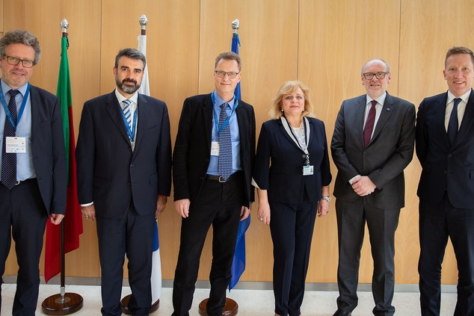

Pictured from left to right: Jakub Boratynski (DG Connect), Evangelos Ouzounis (ENISA), Jesper Rasmussen (EASA), Maja Markovcic Kostelac (EMSA), Josef Doppelbauer (ERA), Per Haugaard (DG MOVE)

Tagged with

* [cybersecurity](https://www.enisa.europa.eu/search?Subject%3Alist=cybersecurity)
* [Transport](https://www.enisa.europa.eu/search?Subject%3Alist=Transport)

170 public and private partners from all over Europe and representing all transport modes took part in the event. Together, they discussed the EU legal framework for cybersecurity, its relevance for the transport sector, and explored options for further cooperation.

Udo Helmbrecht, Executive Director of ENISA stated that "ENISA is honoured to organise this pioneering conference on Transport Cybersecurity with our partners DG MOVE and the relevant EU Agencies. It paves the way for a joint collaboration with DG MOVE and fosters cooperation to progress the policy for cybersecurity in the transport sector across the EU borders, protecting and safeguarding the security of the end-users and its digital ecosystem. ENISA will continue to drive its efforts established in the NIS Directive in the air, rail, road and maritime transport sector."

The Conference hosted a series of interesting presentations and discussion panels, during which several topics were discussed that could enhance collaboration between the sectors’ operators: the welcome session and panel focused on collaboration between the Transport Agencies, ENISA and the European Commission by setting a common portfolio. DG CNCT presented the Cybersecurity Act, stressing the importance of collaboration with Transport stakeholders under the topic of certification. The demanding regulatory framework was next in the agenda and ENISA moderated a session comprised by public and private representatives of the sectors, touching upon the need for a common framework.

DG MOVE moderated the next session on lessons learnt from cybersecurity incidents, which actually showed that the sectors share indeed many commonalities. Finally, the need for intra-sector and inter-sector collaboration was highlighted in the last session, where the ISAC model was one of the topics discussed.

This conference paved the way for a fruitful collaboration between agencies as well as operators.

The key outcomes of the conference are underlined in the Joint statement, which is available at <https://ec.europa.eu/transport/sites/transport/files/2019-01-23-1st-transport-cyber-security-conference-conclusions.pdf>.

Watch the video produced by EMSA with statements from keynote speakers: <https://www.youtube.com/watch?v=Llz6leuSWls>